20-08-2026

EXPERIMENT 27 – FRUIT COLOR USING BACKTRACKING

AIM
To write a Prolog program to find the color of fruits using backtracking.

ALGORITHM
- Start the program.
- Define facts containing fruits and their colors.
- Create a rule to find the color of a fruit.
- Query the fruit or color.
- Use backtracking to find all matching results.

PROGRAM
fruit(apple, red).
fruit(banana, yellow).
fruit(orange, orange).
fruit(grapes, green).
fruit(mango, yellow).
fruit(guava, green).

find_color(Fruit, Color) :-
fruit(Fruit, Color).

OUTPUT

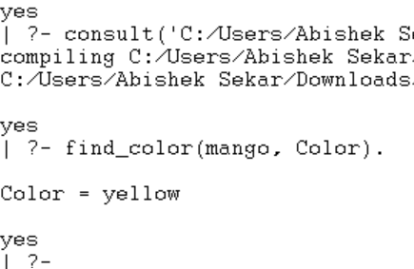

RESULT
Thus, the fruit-color program was successfully implemented using Prolog backtracking.

